Go to TFS -> Select the project -> click on the setting icon at the top middle (near Test menu) -> click on Agent queues -> click on the download agent button shown below and download the agent & copy to drive (say ‘D’) on the TFS installed server.

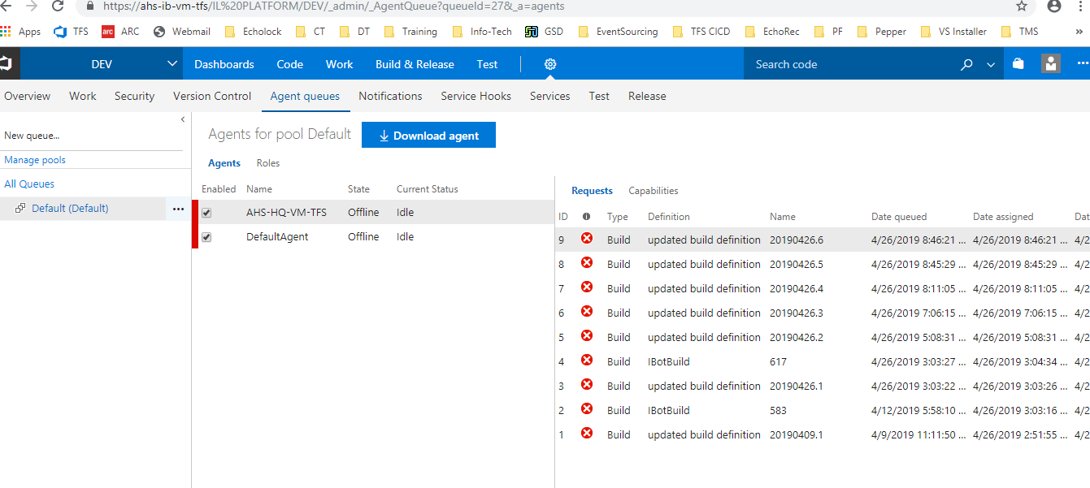

Extract the agent zip

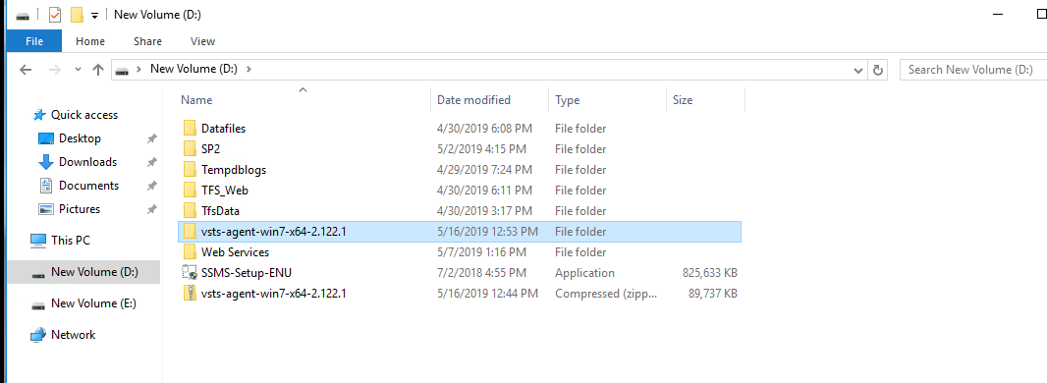

**Command prompt from this folder (Run as administrator)**

D:\vsts-agent-win7-x64-2.122.1> .\config.cmd

>> Connect:

Enter server URL >

Enter server URL > https://ahs-ib-vm-tfs/IL%20PLATFORM

Enter authentication type (press enter for Integrated) >

Connecting to server ...

>> Register Agent:

Enter agent pool (press enter for default) >

Enter agent name (press enter for AHS-IB-VM-TFS) >

Scanning for tool capabilities.

Connecting to the server.

Successfully added the agent

Testing agent connection.

Enter work folder (press enter for _work) >

2019-05-16 07:37:38Z: Settings Saved.

Enter run agent as service? (Y/N) (press enter for N) > Y

Enter User account to use for the service (press enter for NT AUTHORITY\NETWORK SERVICE) >

Granting file permissions to 'NT AUTHORITY\NETWORK SERVICE'.

Service vstsagent.ahs-ib-vm-tfs.AHS-IB-VM-TFS successfully installed

Service vstsagent.ahs-ib-vm-tfs.AHS-IB-VM-TFS successfully set recovery option

Service vstsagent.ahs-ib-vm-tfs.AHS-IB-VM-TFS successfully configured

Service vstsagent.ahs-ib-vm-tfs.AHS-IB-VM-TFS started successfully

D:\vsts-agent-win7-x64-2.122.1>

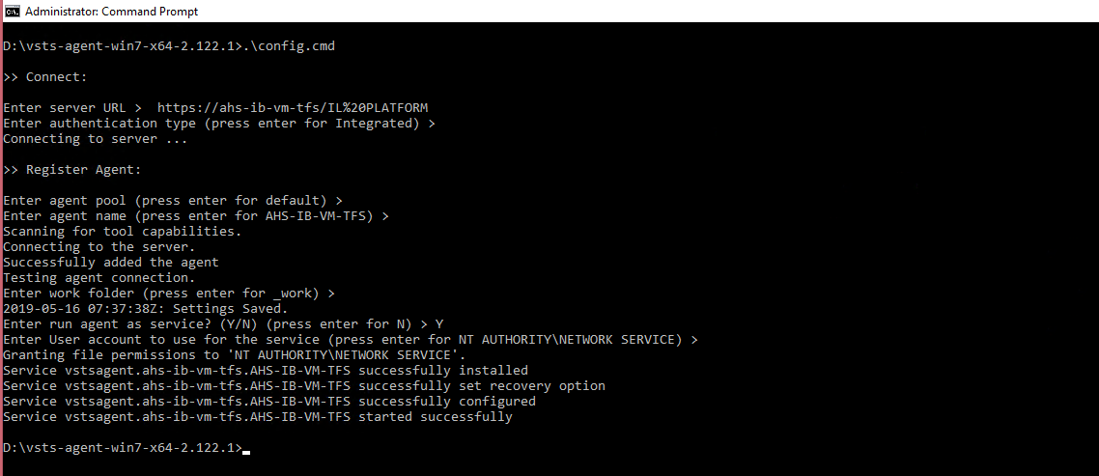

Type services.msc in windows services and go to services



Make sure the build agent is running as shown below.

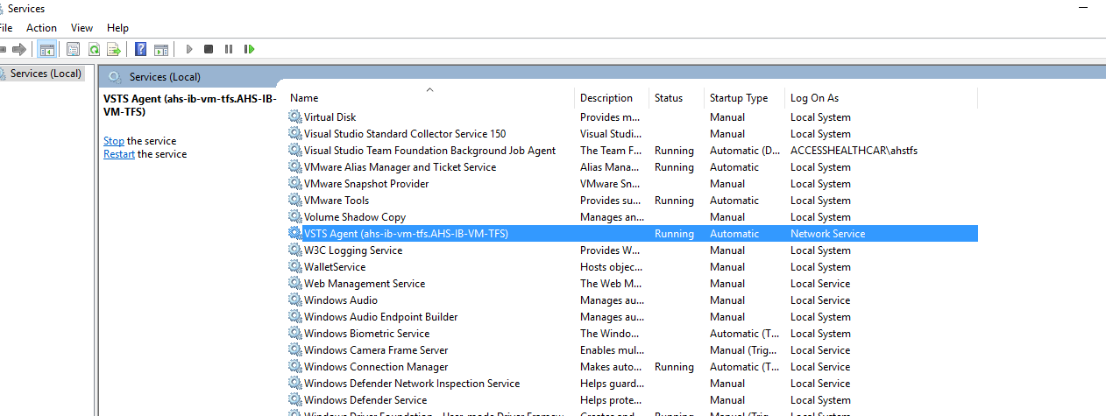

Go to TFS URL -> Sepcific project -> hover over settings icon -> click on the agent queues -> validate the build agent is listing here with a status of online green as shown below

